* **SCM** - Source Code Management

Source Control management

Software Configuration Management

SCM is to change the modifications or track the modifications in a file and also a number of multiple users can use this.

* **Version Control -** When we change the modifications or track the modifications or to find who changes the modifications by using a version called version control management. Simply SCM is maintained or to control the files by using versions called Version Control Management system.

It allows multiple users to manage multiple revisions of the same unit of information.

* **Types of version control source code management system**
* **Centralised version Control System** In this the versions are directly connected and saved to server and also no local repository . The main drawbacks are that internet connection was regularly connected and once the server repository crashes, total versions which are directly connected with versions are also crashes. Eg :- SVN
* **Distributed version Control System** In this between server remote repository and Versions there is local repository present . First version control connected to the local repository . Advantages is once a server crashes there is back up with any of the local repositories. Load on the server also less. Eg :- GIT
* **What is GIT?**

GIT is a distributed version control system and it is easy to download , free open source , used to manage different versions of the source code , and provides a command line to interact with the files.

* **What is GITHUB?**

Github is a version control system and it is hosted on the web . It is not downloaded . We work on a web server only. It lets you and others work together on projects from anywhere.

* **We are working GIT in a cloud environment that's why we go with EC2 instance**
* **Step 1 :-**  Launch an new instance in EC2
* **Step 2 :-** Then copy the IP Address and open in Putty
* **Step 3 :-** Change yourself to root user by using command sudo su -
* **Step 4** :- Change the IP name by using command hostname

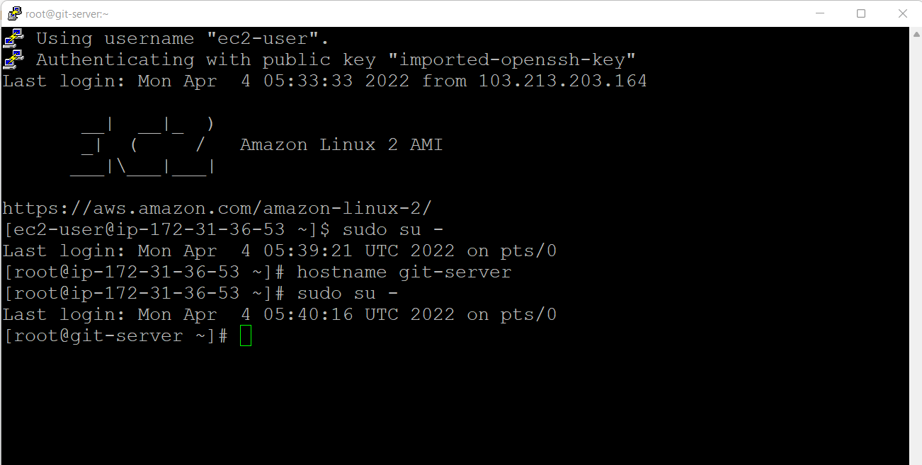

* **Step 5 :-** Type command **yum update -y**

To see any updates found from amazon side . If there are no updates found then we no need to update.

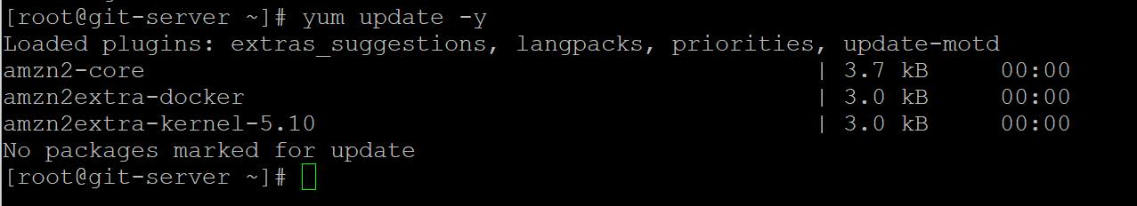

* **Step 6 : -**  Run command git

It shows git command not found it means it is not installed

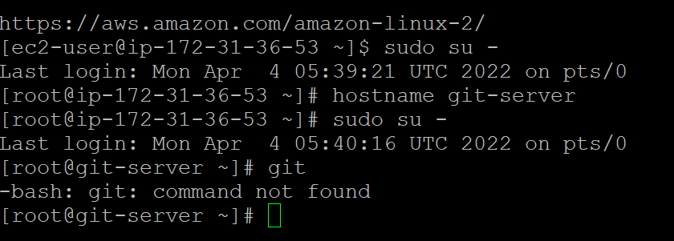

* **Step 7 : -** Run command **yum install git -y**

It is for to install git

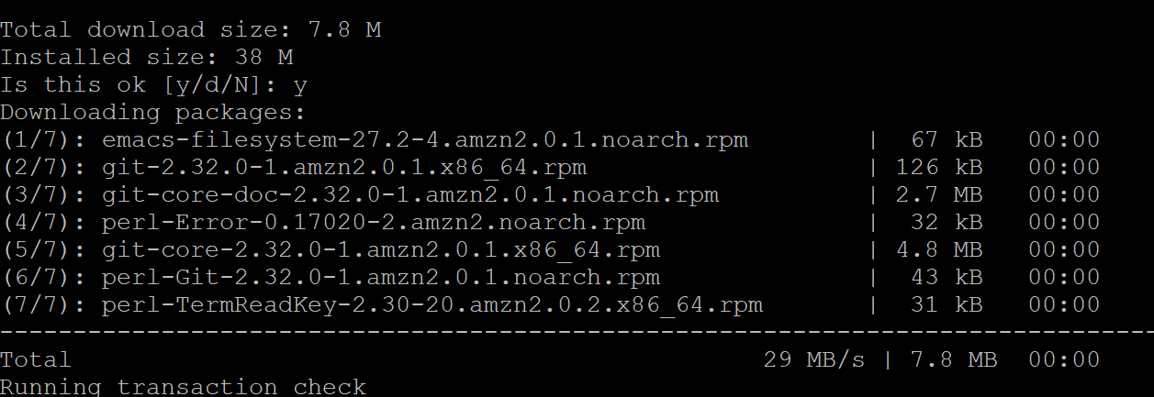

* **Step 8 : -** Run command **git —version**

To know the version of git

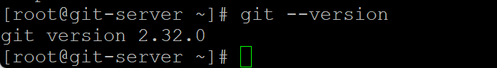

* **Step 9 : -**  In this we have to connect git with github. Before this task we have to create an account in github. In github we have username and mail address.

Run command **git config –global user.name** “lokasainadh”

Run command **git config –global user.email** “k.lokasainadh@gmail.com”

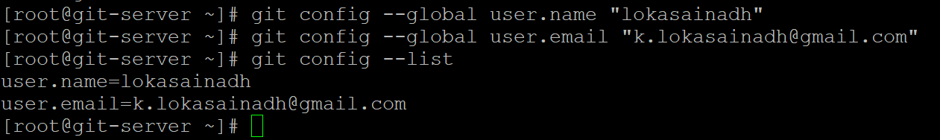

* **Step 10 :-** Run command **git config –list**

Then it displays user name & user email in it. It means it connected with github

* **Step 11 :-** We have to create a repository for that we have to make changes in settings.

Open settings → Developer settings → Personal access token → Generate new token → give any name to note like eg sample token → select all those scopes → Generate token.

New token generated , copy the token now

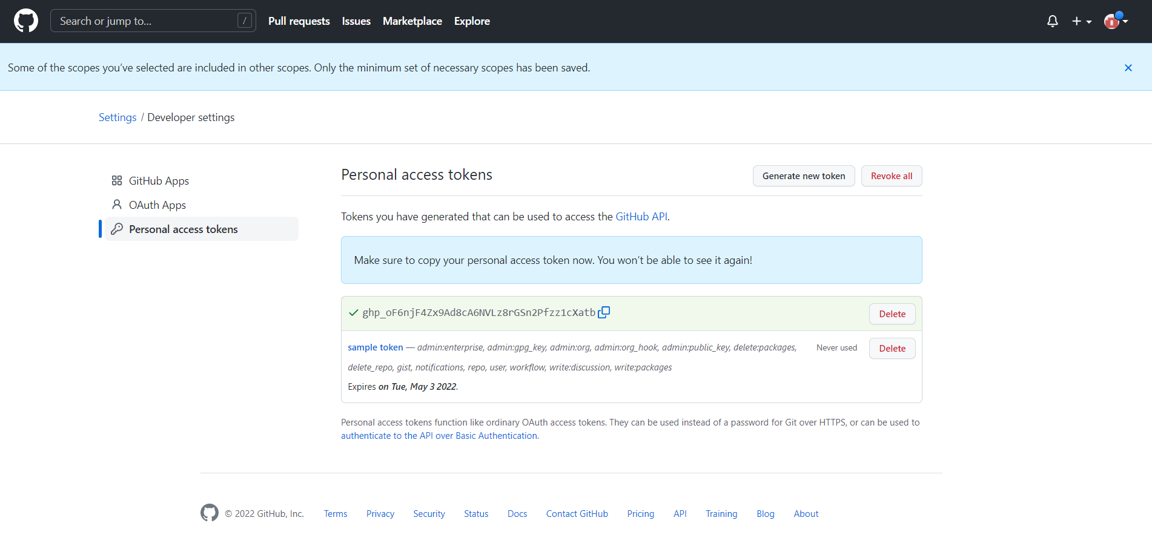

* **Step 12 :-** Create a new repository

Select public in it

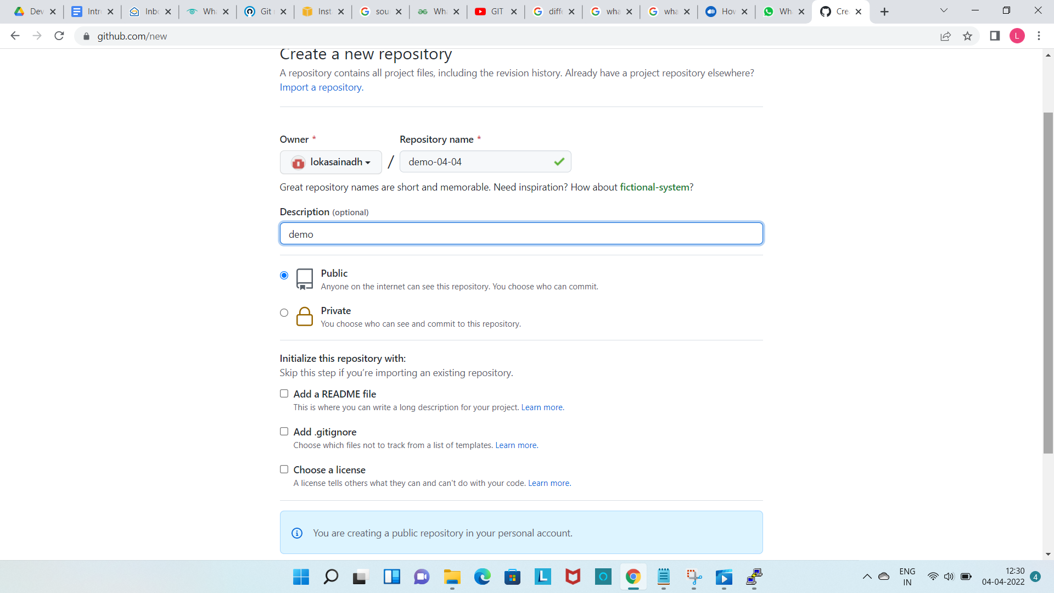

* **Step 14 :-** We have to execute this commands

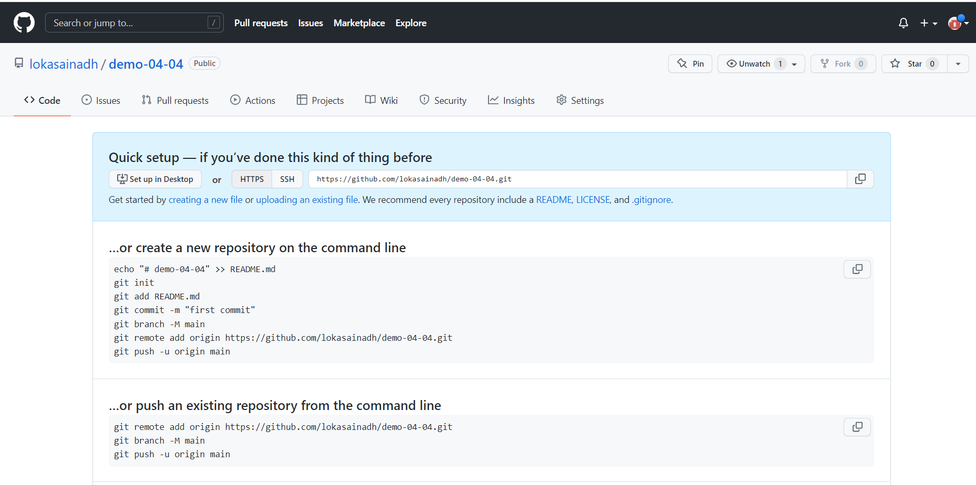

* **Step 15 :-** Create a directory with name demo-04-04

Run command mkdir demo-04-04

Then run command cd demo-04-04

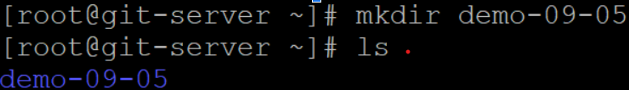

* **Step 16 :-** The above is a normal directory and we have to create a git directory means local repository by using command git init

Run Command **git init**

Then an empty repository with .git was created.

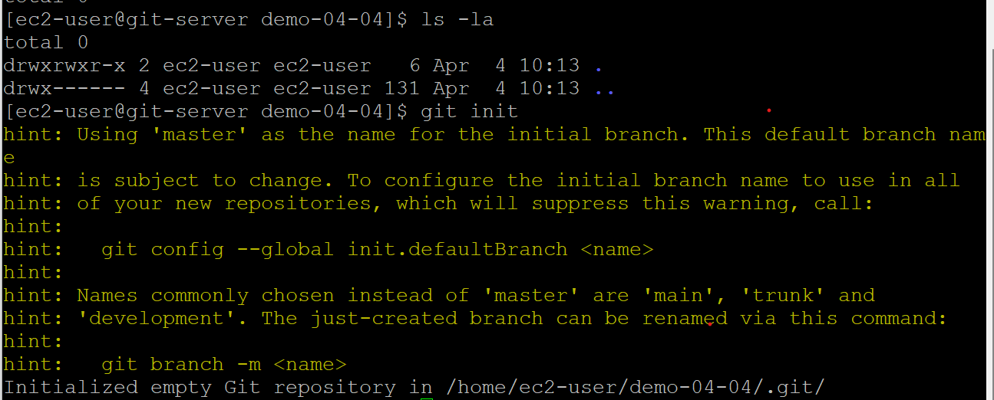.

* **Step 17 :-**  Create a file with nano or vi editor nano sample.txt and enter some line and when you check with a command **git status** it shows that text file in red colour and it shows to use command **git add** for to add the file to staging area to commit.

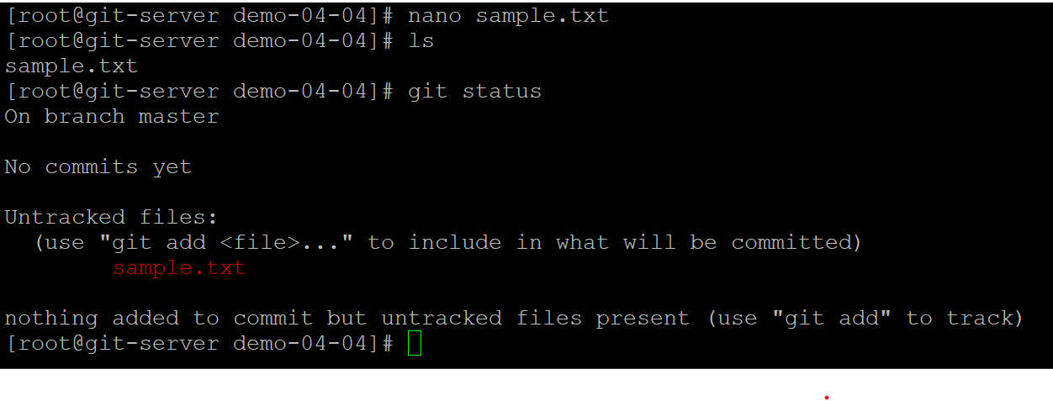

* **Step 18 :**- when we use the command git add then the text file goes to staging area

**git add sample.txt**

means we first only discussed that it is a distributed version control system & it has a working repository , local repository and then a remote repository.

***Working tree —> Staging area —> local branch —> Remote tracking —> Remote branch***

We made the changes in working area & then to staging area by giving command git add & then it staging area to local branch

git rm –cached <file.txt> for unstage

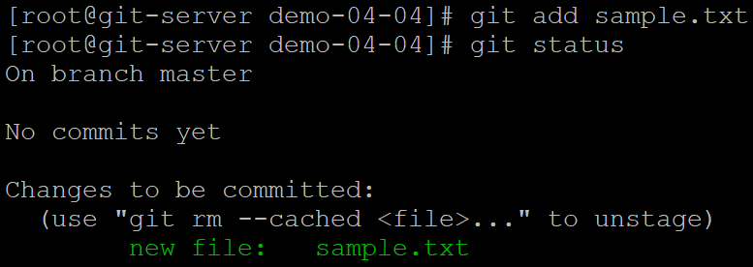

* **Step 19 :**- use command **git commit -m “first commit”** to send this from staging area to local branch . Git commit is used to find out the changes made or track the changes made.

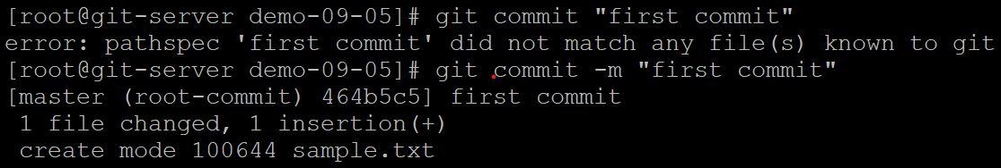

* **Step 20 :**- the branch name is master git has to change the branch name to main so here we use the command **git branch -M main** why because master is an offensive word.

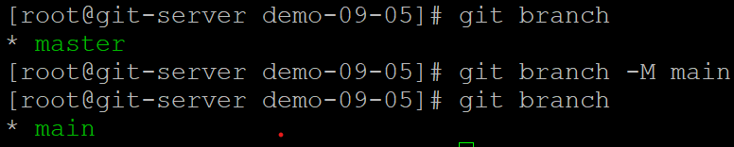

* **Step 21 :**- For the remote tracking use the command git remote add origin URL given by github simply copy & paste it. To simply reduce the command use command **git remote -v** means this argument -v refers to the whole origin.



* **Step 22 :**- use git push command for to send to github by using this command

**git push -u origin main**

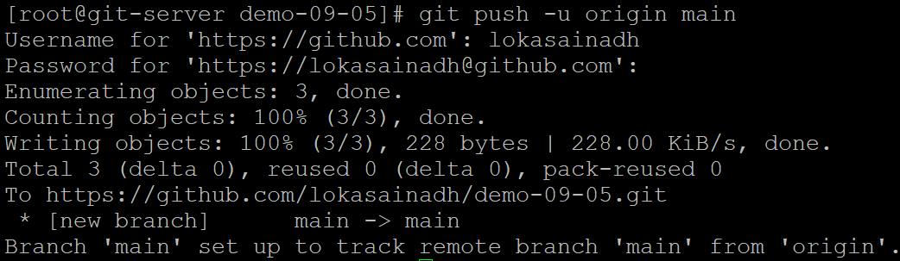

In the above it is 100% done means the new branch name with main set to track to the main remote branch from origin.

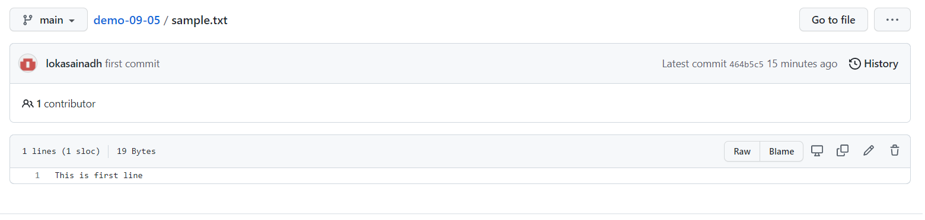

If we want to get that code from remote to local we use the command **git clone** and then that repository URL.